

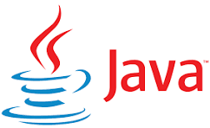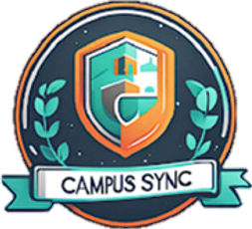

**Mentor: Prof. Dr. Jitender Tanwar**

**SHOBHIT TIWARI –** [**shobhit.24scse1290006@galgotiasuniversity.ac.in**](mailto:shobhit.24scse1290006@galgotiasuniversity.ac.in)

**ALOK SHAW –** [**alok.24scse1290023@galgotiasuniversity.ac.in**](mailto:alok.24scse1290023@galgotiasuniversity.ac.in)

**AMAN PATEL –** [**aman.24scse1260003@galgotiasuniversity.ac.in**](mailto:aman.24scse1260003@galgotiasuniversity.ac.in)

**COURSE CODE: (R1UC304C)**

**B.TECH. THIRD SEM (2025 -2026)**

**“A Java-Based Web Application with JDBC, Servlets & MySQL Integration”**

**Campus Sync connects students, faculty, & campus services in one platform**

**Campus Sync**

**Plot No. 2, Sector 17-A Yamuna Expressway, Greater Noida, Gautam Buddha Nagar, Uttar Pradesh, India.**





**PROJECT OVERVIEW**

**THE SYSTEM SUPPORTS:**

* Student attendance tracking
* Marks management
* Assignment upload & distribution
* Notice publishing
* Student & faculty management
* Centralized authentication system
* Tech Stack Used:  
  Java • JSP • Servlets • JDBC • MySQL • Tomcat • Maven

CampusSync is a web-based college management system developed using Java Servlets, JSP, and JDBC. The purpose of this platform is to simplify and automate the essential academic and administrative processes within an educational institution. The system provides three major user roles—Admin, Faculty, and Student—each with dedicated features designed to enhance efficiency and reduce manual workload. Administrators can manage students, faculty members, and publish official notices. Faculty members can mark attendance, upload assignments, and enter academic marks. Students can log in to view their attendance records, assignment updates, and marks in a centralized manner. CampusSync uses a structured MVC architecture, where Servlets serve as controllers, JSP pages act as the view layer, and DAO classes handle database interactions, ensuring a clean, scalable, and efficient codebase.



**PROBLEM AND SOLUTION**

⚫ **PROBLEM UNDERSTANDING**  
Most colleges still rely on manual or semi-digital systems for managing attendance, marks, assignments, and communication.  
This leads to delays, errors, and inefficiency.

⚫ **PROPOSED SOLUTION**CampusSync processes with a web-driven architecture.  
The solution ensures:

* Faster data access
* Automated workflows
* Accurate records
* Secure login-based operations
* Centralized database for all academic data

⚫ **SOLUTION DESIGN SUMMARY**

1. Admin Module – manages students, faculty, notices.
2. Faculty Module – attendance, marks, assignments.
3. Student Module – view marks, attendance, and notices.
4. MySQL Database – stores all system data.
5. Servlet Controllers – manage request-response cycles.
6. DAO Layer – handles all database interactions.
7. JSP Views – present the UI.



**CORE JAVA CONCEPTS USED**

This project strongly demonstrates Java fundamentals:

**✔ Object-Oriented Programming**

* **Encapsulation:** All models (Student, Faculty, Admin, Assignment) are POJOs.
* **Abstraction:** DAO classes hide JDBC logic from servlets.
* **Polymorphism:** Servlet doGet/doPost overriding.
* **Constructor Overloading** in model classes.

**✔ Exception Handling**

* try/catch
* throws keyword
* ServletException handling for DB and IO exceptions

**✔ Collections Framework**

* **List<Student>, List<Faculty>** used in DAO layer

**✔ Clean, Modular Code**

* Separate packages:
  + com.campussync.servlet
  + com.campussync.dao
  + com.campussync.model
  + com.campussync.util



**✔ JDBC + Java Integration**

* PreparedStatement
* ResultSet
* Connection pooling concept (explained in documentation).

CampusSync demonstrates strong use of core Java concepts. The project makes extensive use of **Object-Oriented Programming**, including encapsulation through POJO model classes such as Student, Faculty, and Admin. Each model class securely stores user-related attributes with getter and setter methods. Abstraction is implemented via DAO (Data Access Object) classes, which hide JDBC logic from the Servlets, ensuring separation of concerns and cleaner code. Method overriding is used in Servlets, especially through the doGet() and doPost() methods, highlighting polymorphism.

Exception handling is consistently applied throughout the system using try–catch blocks and throws declarations, especially in database operations where SQL Exceptions must be safely handled. Java Collections like List<Student> and List<Faculty> are used in DAO classes to store and return structured data. The entire project follows clean, readable coding standards, maintaining modularity through package separation—servlet, dao, model, and util.

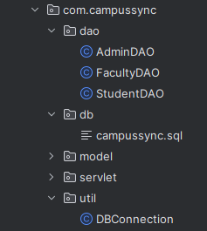



**DATABASE INTEGRATION**

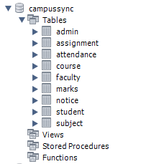

“JDBC is used extensively for all operations.”

**✔ How JDBC Works in This Project:**

1. **DBConnection class** loads MySQL driver.
2. **DAO classes** use PreparedStatement for secure queries.
3. **CRUD operations** performed on all tables.
4. **ResultSet** returns data to JSP via servlets.

* SQL schema includes:
  + student
  + faculty
  + admin
  + subject
  + attendance
  + assignment
  + marks
  + notice

Database connectivity plays a crucial role in CampusSync. The project uses JDBC to connect the application with a MySQL database. A dedicated DBConnection class is responsible for loading the MySQL driver and establishing connections, ensuring code reusability and centralized configuration. PreparedStatement is used across all DAO classes, preventing SQL injection and improving database security. This also enhances performance by precompiling SQL queries.

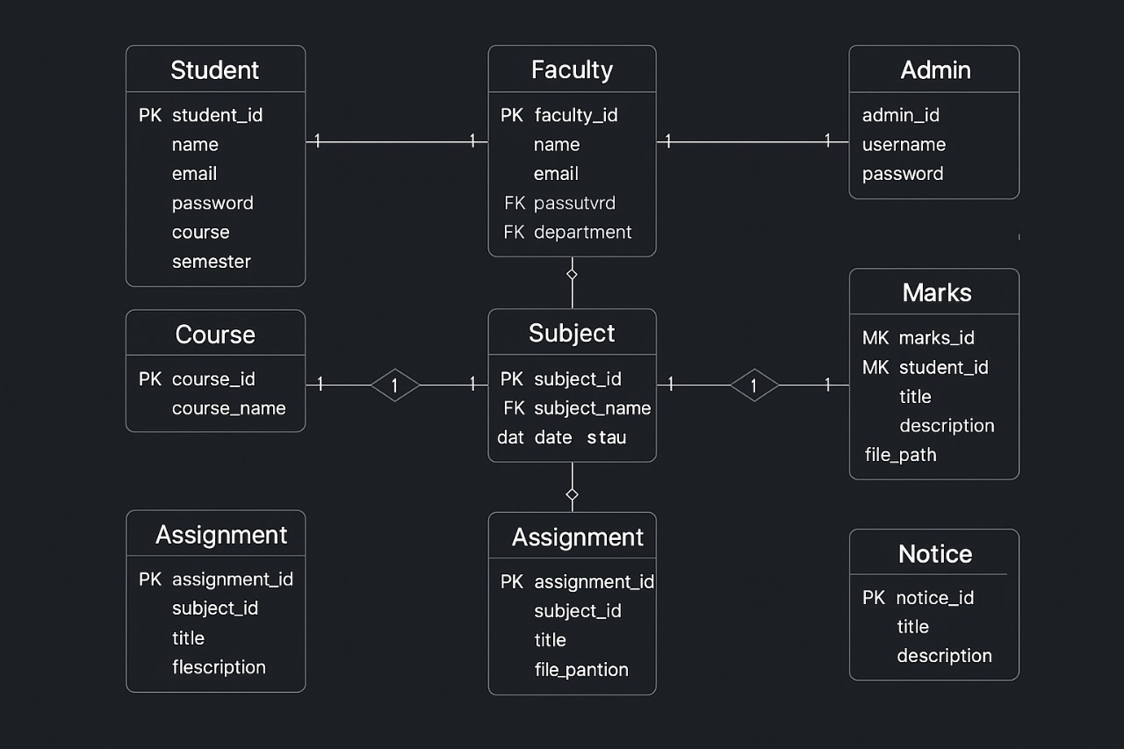

**✔ Security**

* PreparedStatement prevents SQL Injection.
* try-with-resources ensures no memory leaks.

**SCHEMA’S ER DIAGRAM:**

* Student ↔ Attendance ↔ Subject
* Faculty ↔ Subject
* Student ↔ Marks
* Admin publishes Notice
* Assignment belongs to Subject



**✔ Servlets Implemented**

**1. AuthServlet**

* Single login system for all roles
* Session management
* Logout handler

**2. AdminServlet**

* Manage Students
* Manage Faculty
* Publish Notices
* Load admin dashboard

**3. FacultyServlet**

* Mark attendance
* Upload assignments
* Enter marks
* Faculty dashboard

**4. StudentServlet**

* View attendance
* View marks
* Student dashboard
* Only student can view marks/attendance

**SERVLET And Web Intigration**



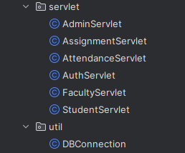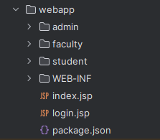

CampusSync uses Servlets as the core controllers for handling HTTP requests and coordinating different modules. Each role has its own dedicated servlet. The AuthServlet manages the authentication system for all three roles and securely maintains sessions. The AdminServlet handles administrative operations like adding students, adding faculty, and publishing notices. The FacultyServlet manages all academic operations including attendance marking, assignment uploading, and entering marks. The StudentServlet retrieves attendance and marks records for display on the student dashboard.

**✔ Web Integration**

* JSP acts as the View
* Servlets act as Controller
* DAO + DB act as Model

**Session validation** ensures secure access:

* Only admin can access admin pages
* Only faculty can mark attendance
* Only student can view marks/attendance



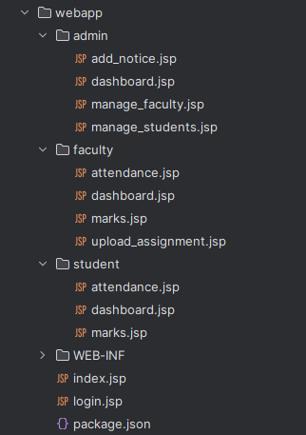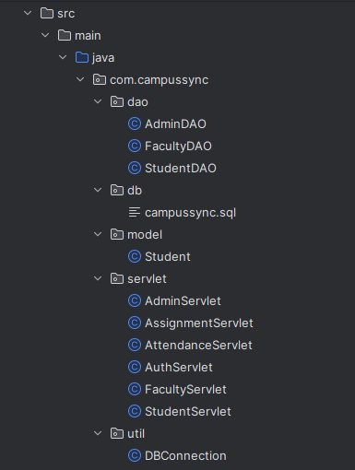

**Client → Servlet → DAO → MySQL → JSP response**

The architecture of CampusSync follows a multi-layered structure. The presentation layer consists of JSP pages responsible for interacting with users. When a user performs an action, the request is sent to a Servlet, which functions as the controller. The Servlet communicates with DAO classes to execute the necessary database operations. DAO classes use JDBC to interact with the MySQL database. Once the data is processed, it is forwarded back to the JSP page for display. This architecture ensures loose coupling, reusability, and ease of maintenance.

**MVC ARCHITECTURE**



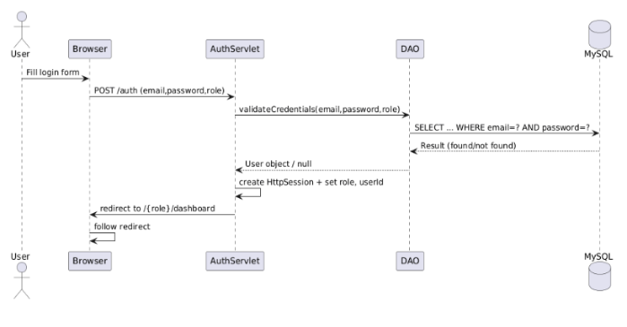

Sequence diagram — Login

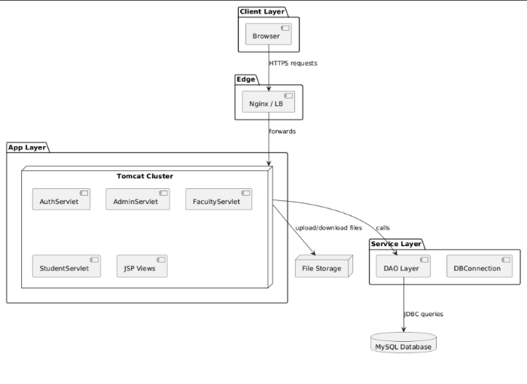

Component diagram

**SYSTEM ARCHITECTURE DESIGN**

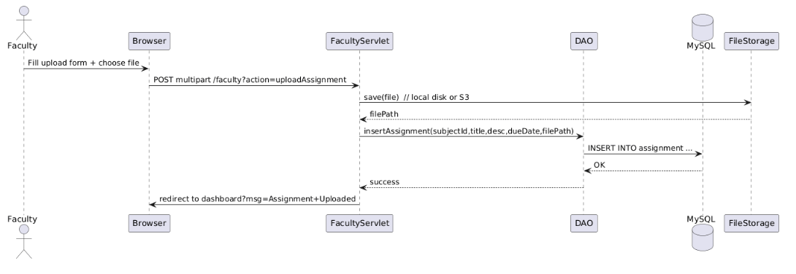

Sequence diagram — Upload Assignment

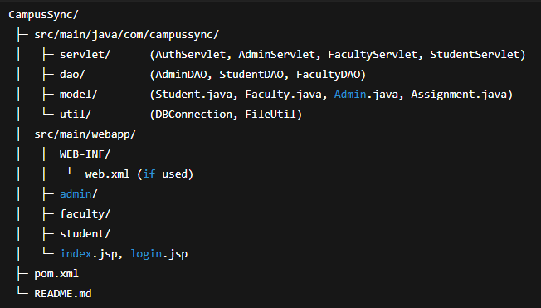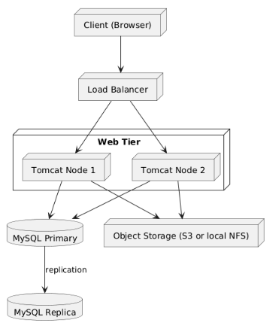

package layout

Deployment diagram



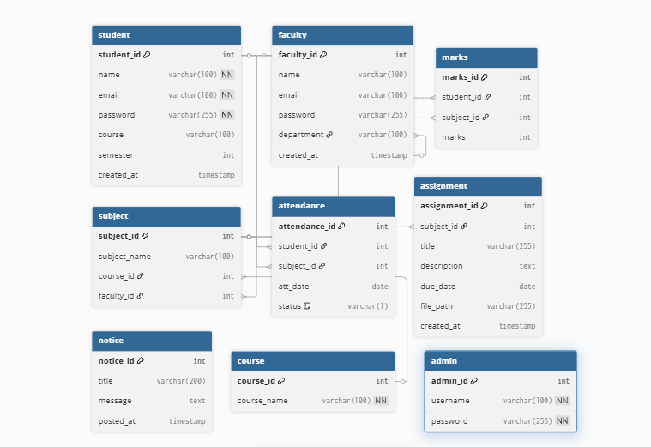

The Entity-Relationship diagram for CampusSync consists of multiple interconnected tables. The student table stores basic student information, the faculty table stores faculty details, and the subject table connects subjects with faculty. Attendance records link students to specific subjects along with dates. Assignment and marks tables store academic submissions and performance metrics. Admins manage notices stored in the notice table. All relationships are designed to ensure data consistency and support smooth academic workflows.

**ER DIAGRAM**

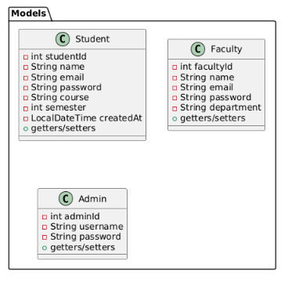

The class diagram highlights the object-oriented structure of the project. Model classes such as Student, Faculty, and Admin encapsulate user data. DAO classes like StudentDAO, FacultyDAO, and AdminDAO implement business logic and handle all database interactions. Servlets serve as controllers managing user requests. The DBConnection class acts as a utility class ensuring unified database connectivity. This structure demonstrates clean OOP implementation.

**CLASS DIAGRAM**

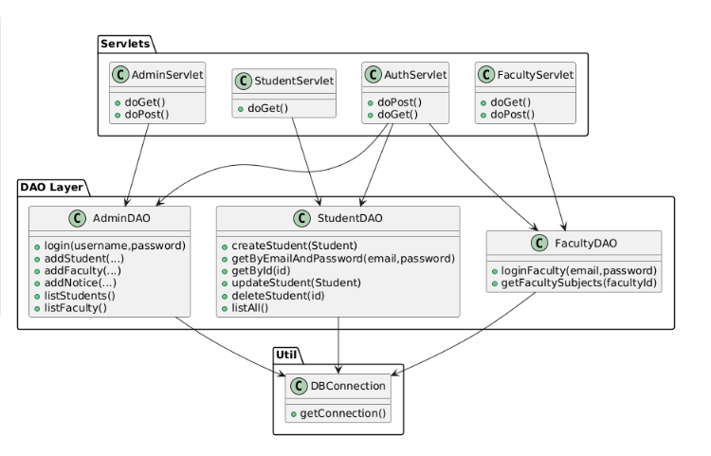

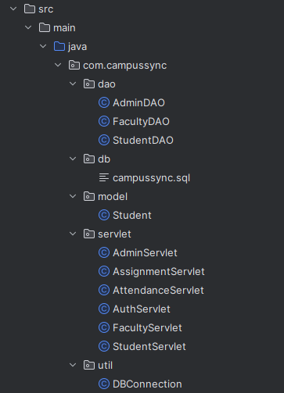



**CAMPUSSYNC — CORE CODE SNIPPETS**

1. Problem Understanding & Solution Design

CampusSync aims to provide a centralized system for student, faculty, and admin interactions:

- Admin manages students, faculty, subjects, courses.

- Faculty manages attendance, assignments, and marks.

- Students view attendance, marks, and assignments.

**HIGH-LEVEL ARCHITECTURE**

Browser (JSP)  
↓  
Servlets (Controller Layer)  
↓  
DAO Layer (Database Logic)  
↓  
MySQL Database

The JSP pages act as the user interface where students, faculty, and admins submit actions like login or attendance. These requests are sent to Servlets, which work as the controller layer—processing input, applying logic, managing sessions, and deciding what to do next. When data needs to be saved or fetched, the servlets call the DAO layer, which contains all the database code using JDBC. DAO interacts directly with the MySQL database by running SQL queries and returning results back to the servlet. Finally, the servlet forwards the processed data back to a JSP page to display it to the user.

**SCREENSHOTS**



Core Java Concepts (OOP + Encapsulation + Constructors)

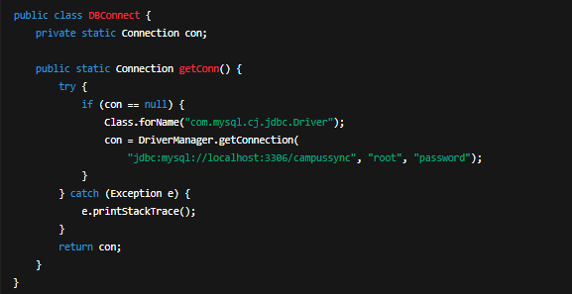

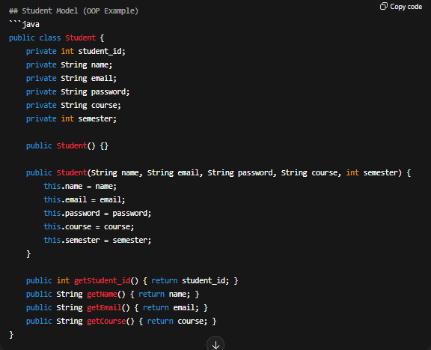

JDBC Integration Snippet (Database Layer)



StudentDAO – Insert Operation (Prepared Statement)

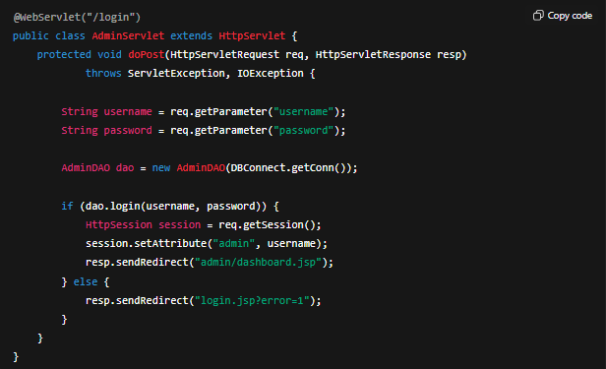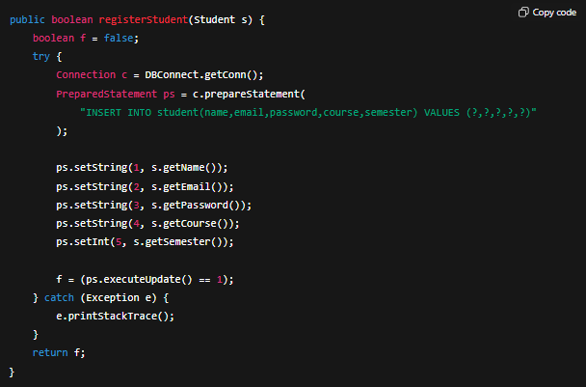

Login Servlet (HTTP + Session + Controller Logic)



Login Servlet (HTTP + Session + Controller Logic)

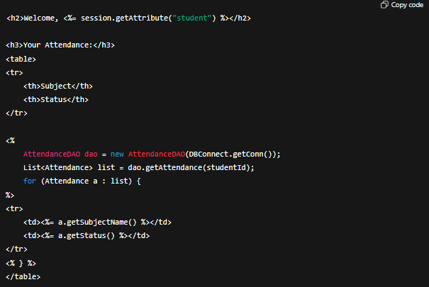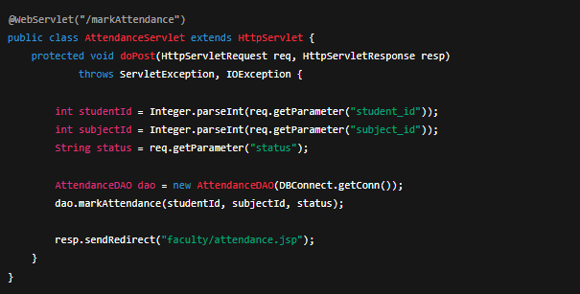

Attendance Servlet (Faculty Example)



Assignment Upload (File Handling Logic)

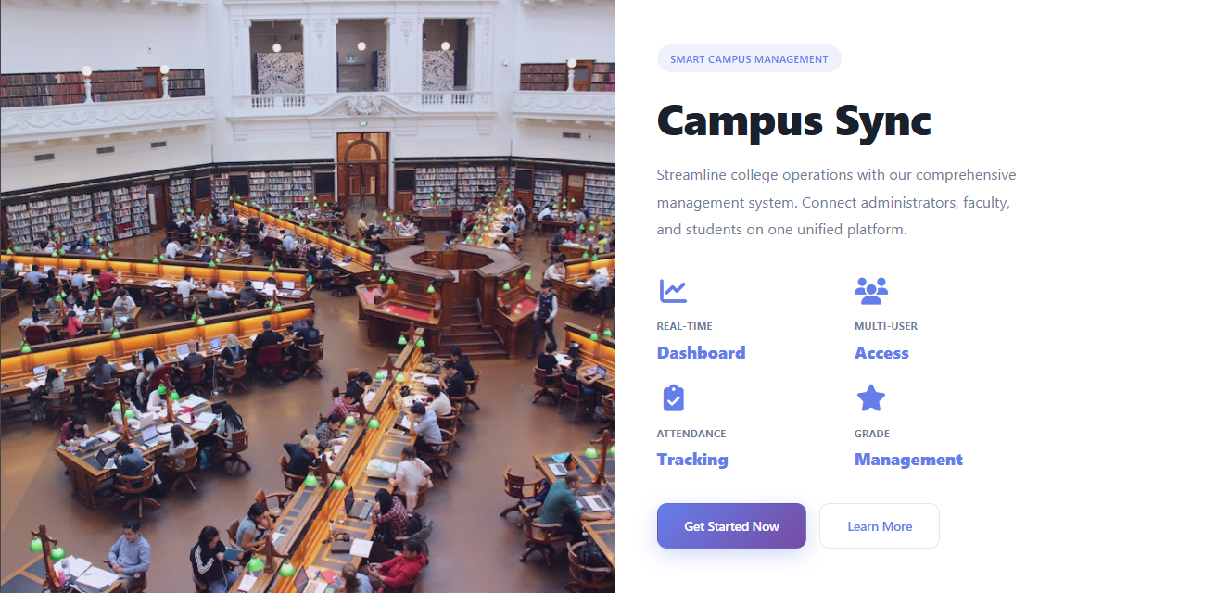

SCRCEENSHOTS FROM PROJECT WEBPAGES

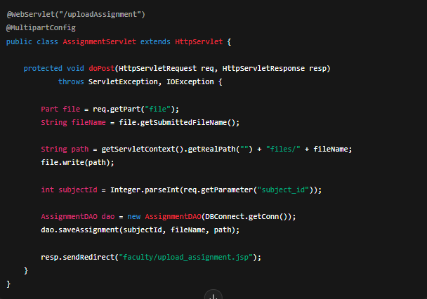

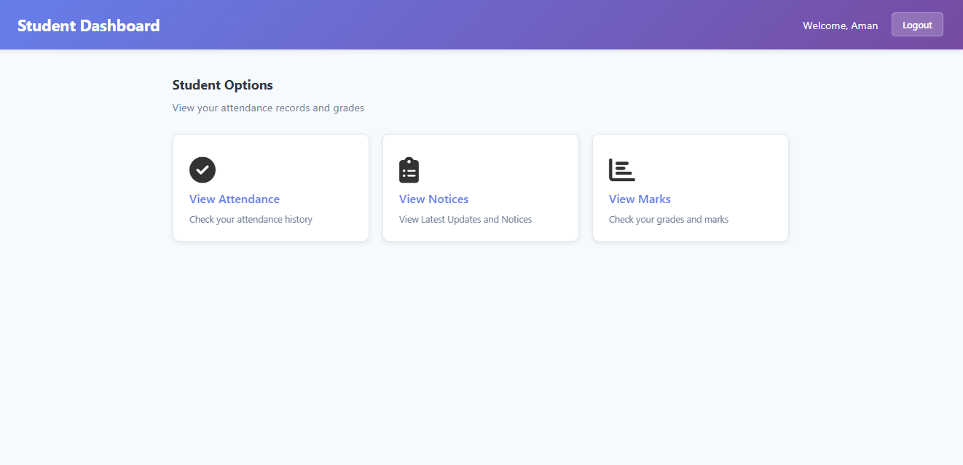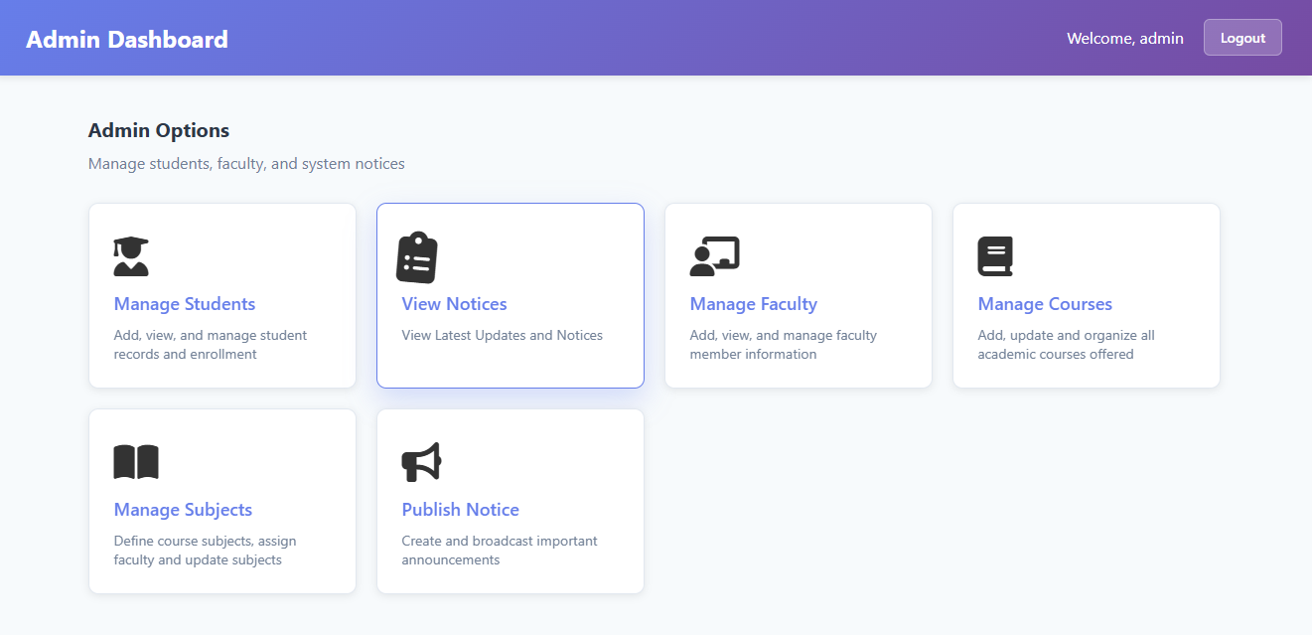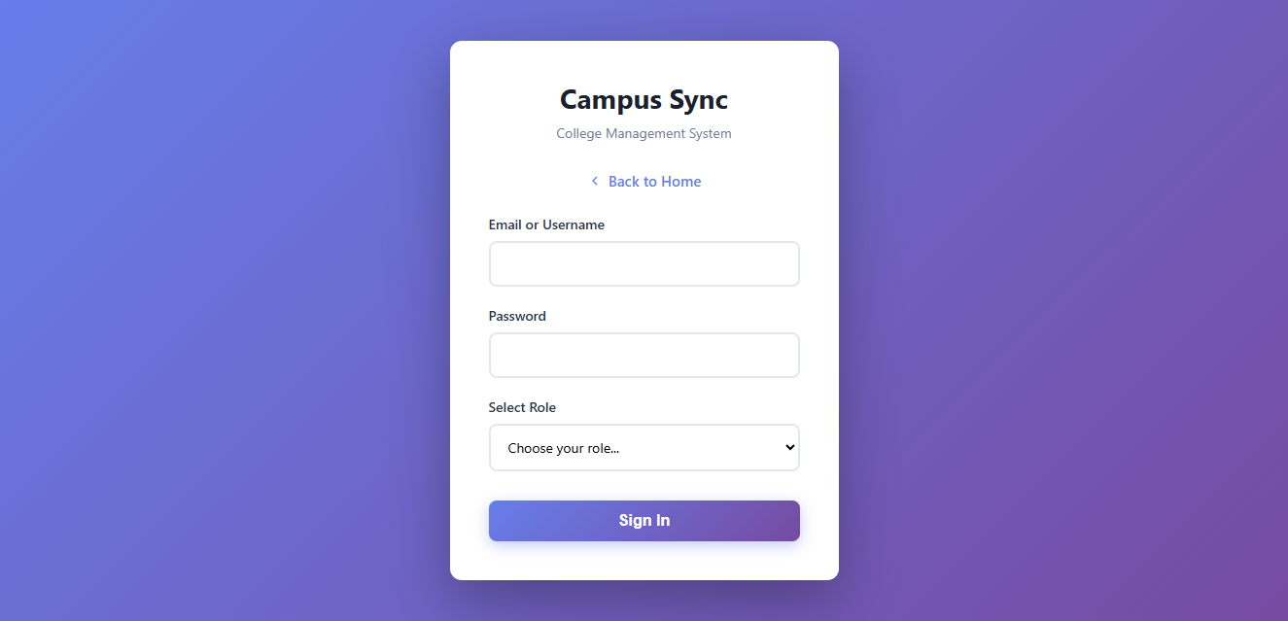

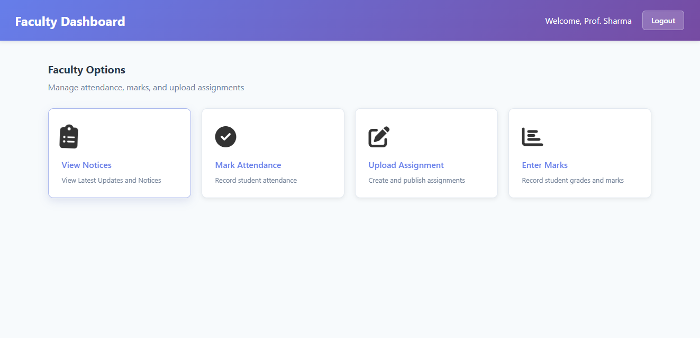

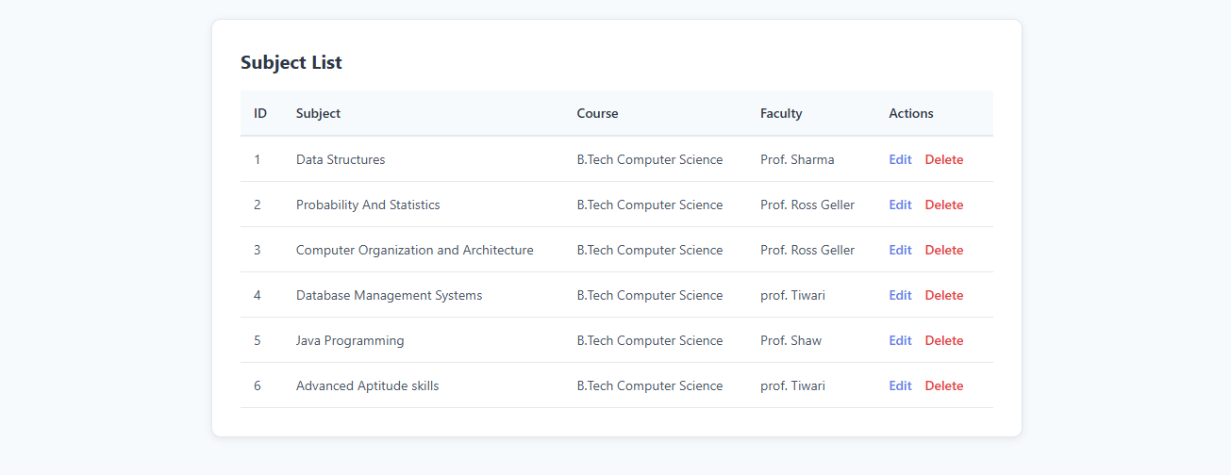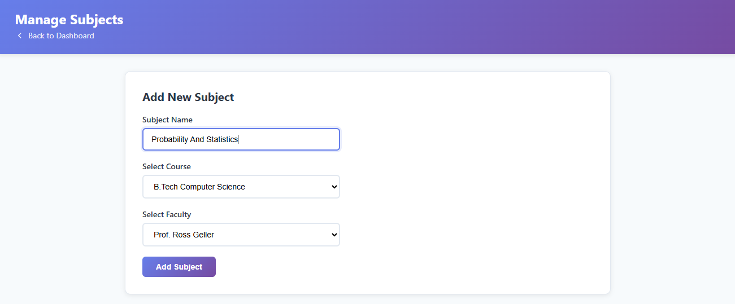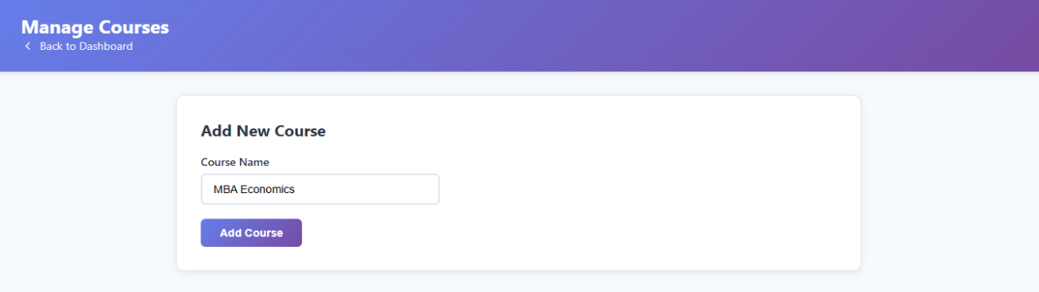

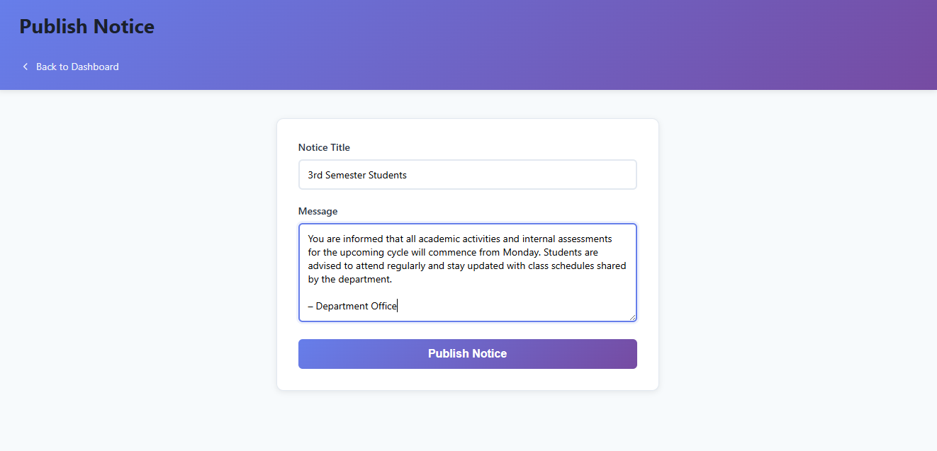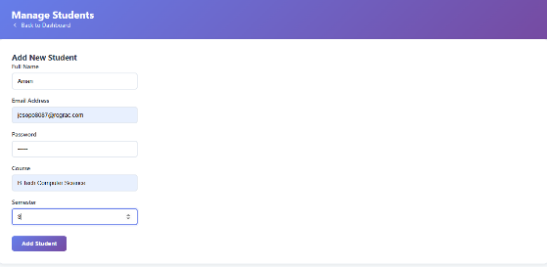

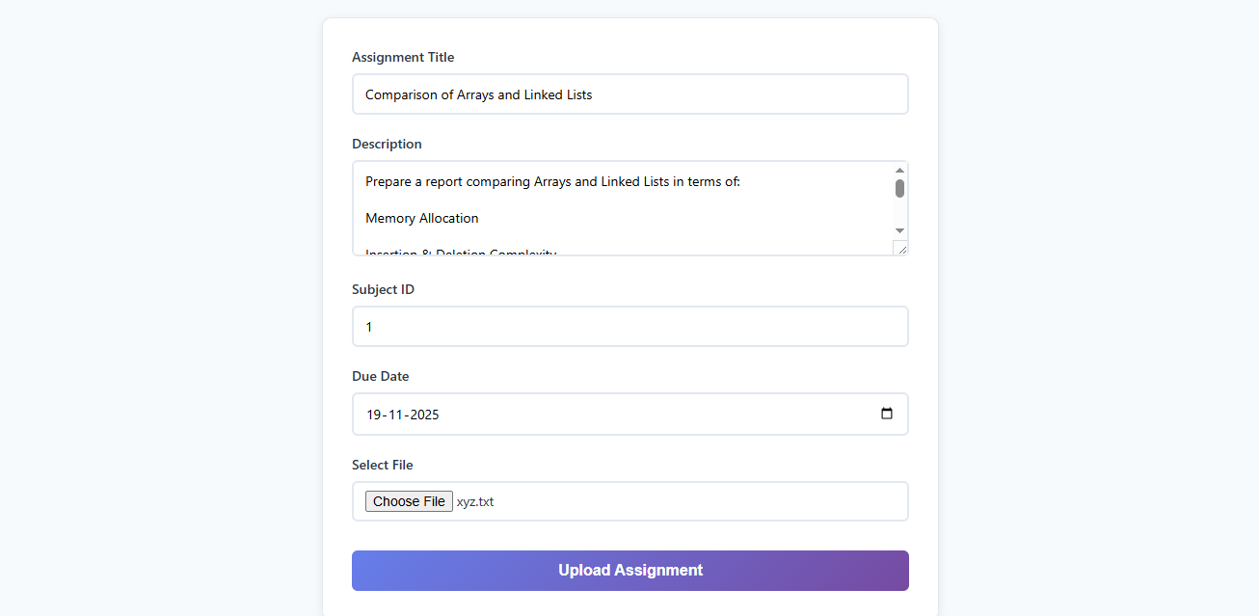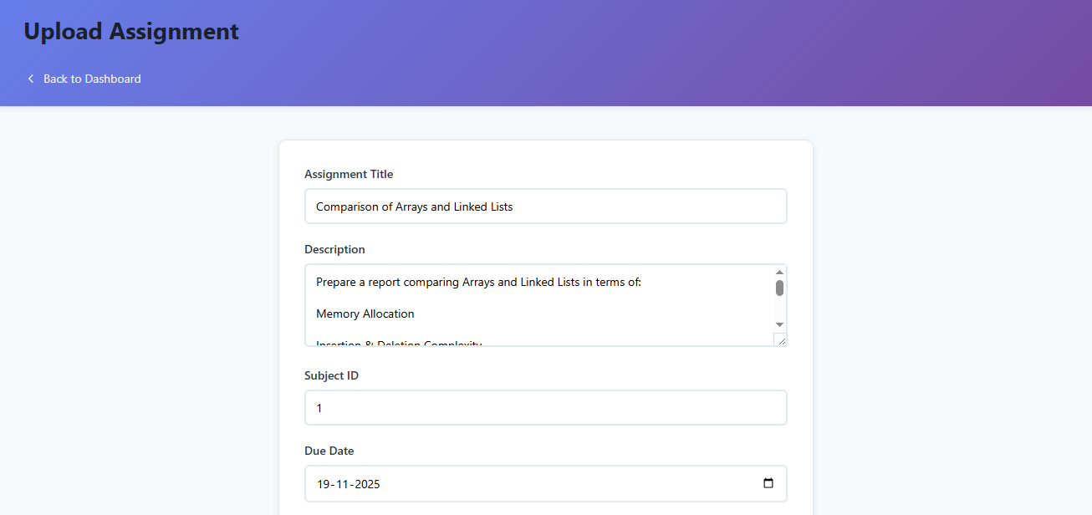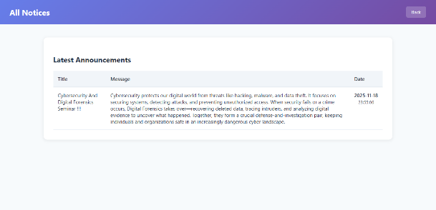

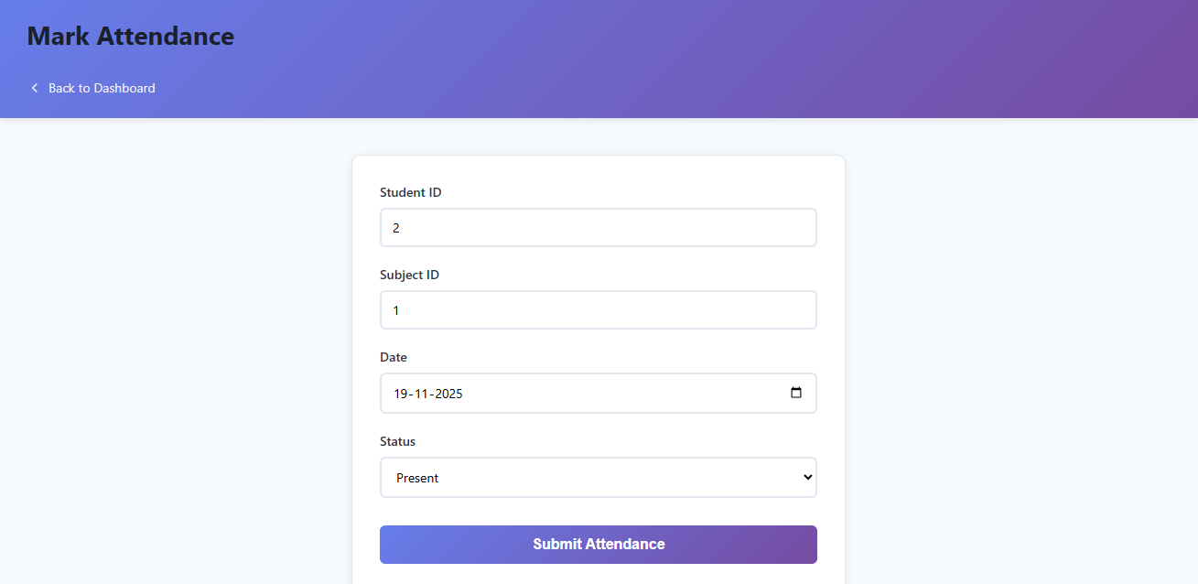

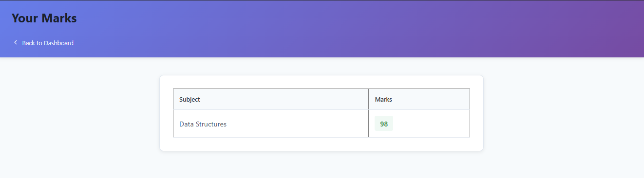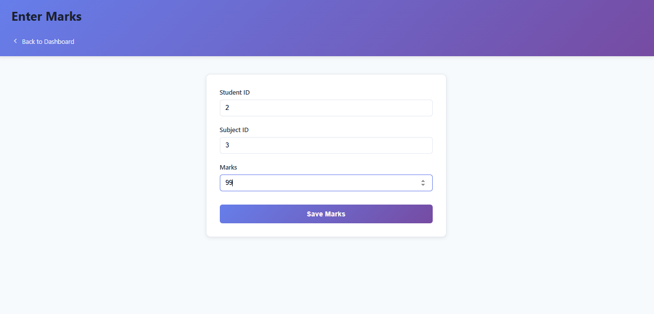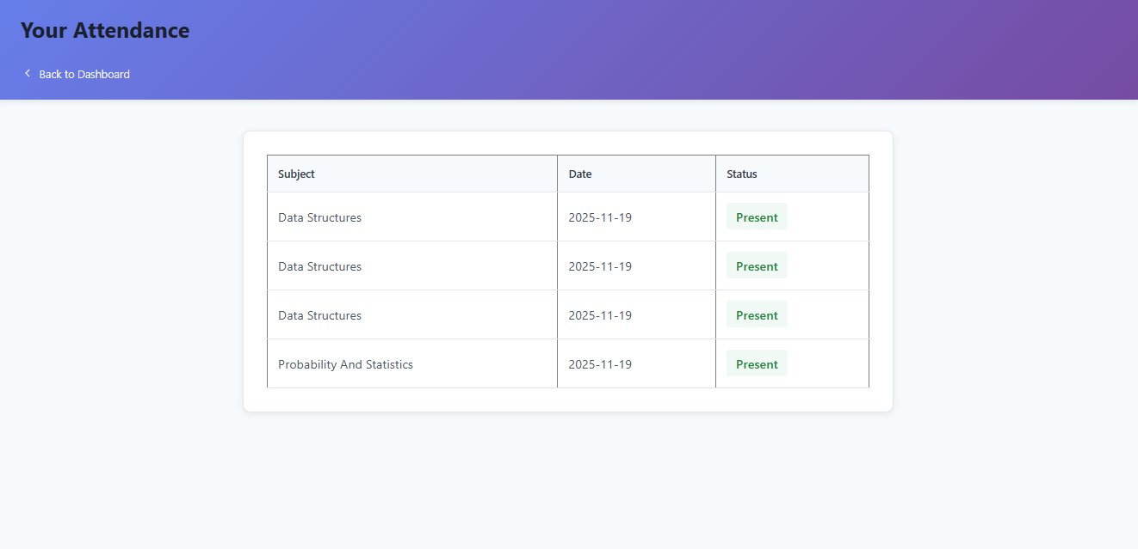

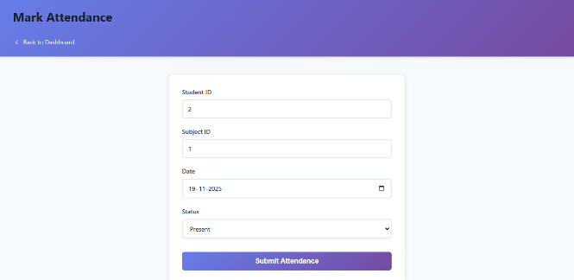

[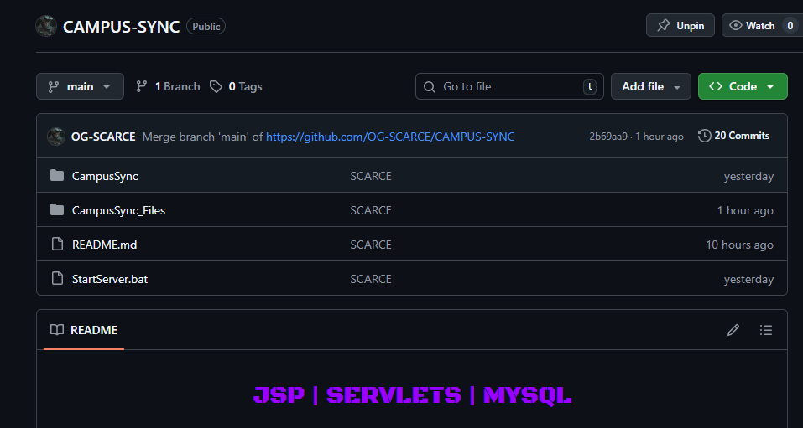](https://github.com/OG-SCARCE/CAMPUS-SYNC)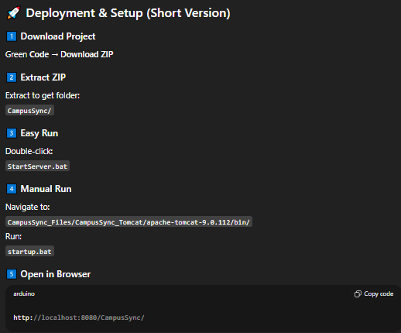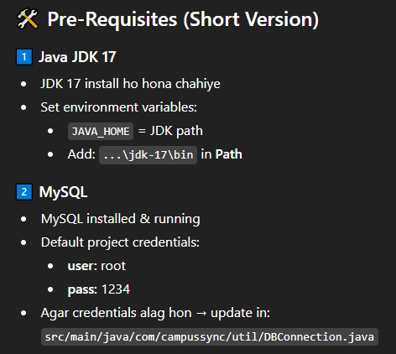

**GITHUB AND RUN INSTRUCTIONS**



The *Campus Sync* system successfully demonstrates a modern, structured, and efficient approach to campus management using JSP, Servlets, JDBC, and MySQL. By implementing the MVC architecture, the project ensures a clear separation of concerns, making the application easier to maintain, scale, and extend.

The system provides dedicated portals for administrators, faculty members, and students, each designed to streamline their respective academic operations. With features such as role-based authentication, student data handling, attendance management, assignment upload, marks handling, and notice broadcasting, the platform centralizes essential campus activities in a unified environment.

The use of JDBC-based DAO classes ensures secure and optimized communication with the database, while Tomcat serves as a reliable deployment server for dynamic web content. The folder structure is modular, organized, and aligned with industry standards, making the project suitable not only for academic submission but also real-world deployment with minor enhancements.

Overall, *Campus Sync* demonstrates strong understanding of Java web technologies and backend-driven application design. It stands as an effective, functional, and scalable solution for institutional workflow automation. With further improvements—such as integrating REST APIs, adding responsive UI, or implementing role-based analytics—the system can evolve into a complete enterprise-grade campus management platform.

**CONCLUSION**



